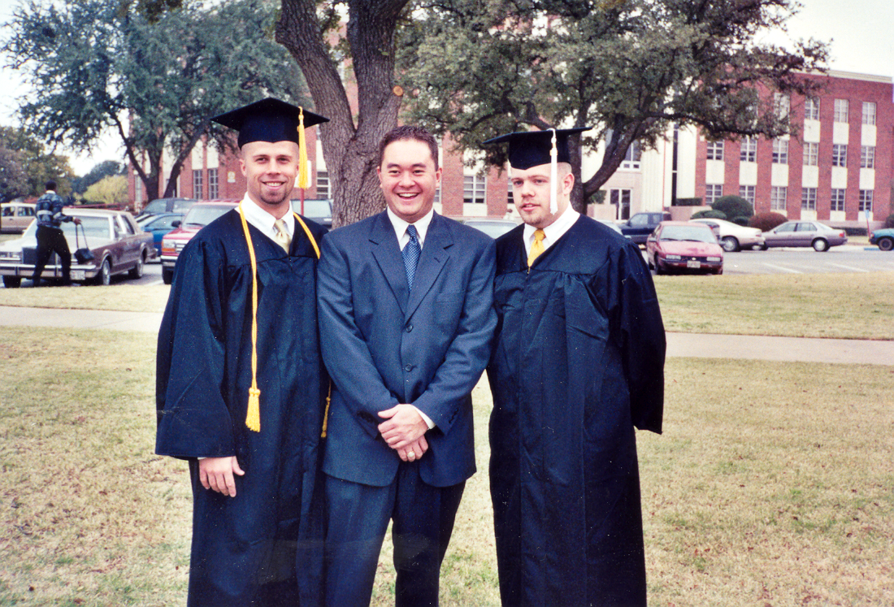
(Micah is one the left with the gold tassels.)

My name is Keith Geeding, and I was asked to represent Micah’s college friends, specifically the thoughts of Richard Bone, Tim Richardson, John Tunnell, Jimi Clark, Keith Johnson, Gabe Waggoner, Mitch Ables, DJ Gililland, Justin Potter, Leah Dubber and Teresa Plotts.

²²But the fruit of the Spirit is love, joy, peace, patience, kindness, goodness, faithfulness, ²³gentleness and self-control. Galatians 5:22-23

Our friend Jimi Clark once said that no one exemplifies the fruit of the Spirit more than Micah. And I completely agree.

Matthew 18: 3-4
³And Jesus said: "I tell you the truth, unless you change and become like little children, you will never enter the kingdom of heaven. ⁴Therefore, whoever humbles himself like this child is the greatest in the kingdom of heaven.

Is there anyone else that has been more childlike than Micah? From just being a real happy person, to that quirky little smile, to his love of Disney’s Toy Story, his ability to fall asleep almost anywhere at any time, to his dream of swimming in a bowl of milk, to his love for Frosted Brown Sugar Cinnamon Pop Tarts, to his sleeveless shirts, to his to his reverent fear of the Lord Jesus. We rejoice that this child has entered the gates of heaven and is wrapped in Jesus’ arms.

Even though he had a child like demeanor, he was also a man of God. Exceptionally trustworthy, dependable, full of character, he was full of integrity. He knew what needed to be done and performed the task with a quiet confidence. As some people are friends only through words, Micah was always more ACTION than words. He was a type of friend that would drive 2 ½ hours to help you move or just to hang out, and he was the type of guy in which you could never tell he was having a bad day. We always admired and was amazed by that second wind, that ability to push himself with a quiet competitiveness, and thanks to Micah, many of us owe our college degrees to him. He was one of the smartest persons we’ve known.

I first met Micah as a freshman at Hardin-Simmons University in Nix Hall in 1994 over a game of ping pong that started about ten at night and lasted to about 2:30 in the morning. From that day our friendship grew, and my close-knit Mineral Wells friends and I adopted him into our group.

As we began to get to know Micah, he shared with us that he was trying to understand the concept of Grace and Salvation. Our former South Side Baptist College pastor Keith Johnson recalls how Micah spent countless time asking questions to all us and researching God’s Word determined to find certainty. There came a point at which Micah understood finally that it is only by faith that we approach a true understanding and relationship with God. His search reminds me of Jeremiah 29:13, “You will seek me and find me when you seek me with all your heart.” The proof of Micah’s findings is found in the life that he lived.

You can see how his personal relationship with Christ grew as he started to become active at South Side Baptist Church and attend GRACE Bible Study with us, attended a Walk to Emmaus, volunteered his time as a counselor at Baptist Encampment Camp Copass on numerous occasions, volunteered at FBC Abilene as a basketball coach for the preteens, and other numerous events. You could see Jesus in his life. He had a favorite praise and worship song, Sanctuary, and he was particularly fond of the little know second verse that reads: “Lord, teach your children to stop their fighting, start uniting as one, and with thanksgiving, I’ll be a living, sanctuary, for you.”

As there is no I in Team, there was no ME in Micah. He gave of himself. He always enjoyed helping people, it was no wonder how he was a natural as a resident advisor in Nix Hall, and you could just see and admire the respect those residents gave him because of his character and compassion for those he served. He had heart, and he was true, and his life can be described by Proverbs 27:19 “As water reflects a face, so a man’s heart reflects the man.”

I remember as his relationship with Christ grew, he made a decision that he wanted to be baptized before he moved to the Houston area for his first teaching job with Pasadena ISD. He wanted to do it in front of those closest to him. So on one summer night a group of us traveled to Lake Ft Phantom for his baptism, and we turned that event into a praise and worship ceremony.

Just because he lived in south Texas didn’t mean we did not keep in touch. He was my prayer warrior and accountability partner, and he strengthened my walk with Jesus. He was an example of Proverbs 27:17, “As iron sharpens iron, so one man sharpens another.” I knew that anytime I needed prayer, he would honor it, and he certainly did when my father passed away. As a matter of fact, he was the first person I called for prayer as I considered to ask my girlfriend to be my wife. I recently found out, that in his prayer journal you will see that every entry over the past few months he has prayed that Kelsey and I have a marriage that will bring glory and honor to the Kingdom of God. We visited much more often when he moved back to Clyde, and he was to be the best man at my up coming wedding this Saturday. He will still be my best man at my wedding because there is no replacing Micah.

As Christians we grieve, but we grieve with hope. Micah understood the difference between believing in Jesus and having an actual personal relationship with Jesus. We grieve with hope because Micah has a personal relationship with Jesus Christ. You too can have a personal relationship with Jesus and join Micah in heaven one day, and if you want to know how, just ask the closest preacher.

A great friend, son, brother, boy friend, student, teacher, coach . . . it didn’t matter what your relationship was with him; he impacted your life and made you a better person. He was my hero, a giant, a real man to measure all men and we will miss him greatly. He is most certainly with Jesus now and I will continue to be touched by him for the entirety of my time on earth. The greatest joy today is knowing that we will spend an eternity together praising God, and I can only imagine . . . .

I can only imagine
What it will be like
when I walk by your side
I can only imagine
What my eyes will see
when your face is before me
I can only imagine
Surrounded by your glory
what will my heart feel?
will I dance for you Jesus?
or in awe of you be still?
Will I stand in your presence?
To my knees will I fall?
Will I sing halleujah?
Will I be able to speak at all?
I can only imagine
I can only imagine
when that day comes
when I find myself standing in the sun
I can only imagine
when all I will do
is forever, forever worship you
I can only imagine.
Surrounded by your glory
what will my heart feel?
will I dance for you Jesus?
or in awe of you be still?
Will I stand in your presence?
To my knees will I fall?
Will I sing halleujah?
Will I be able to speak at all?
I can only imagine

